|  |  |
| --- | --- |
| Topics | Page |
| Introduction | 1 |
| Objective | 2 |
| Procedure | 3 |
| Observations | 4 |
| Conclusion | 5 |
| Bibliography | 6 |

**Index**

**Teachers Certifiacate**

THIS IS CERTIFY THAT MASTER SUMIT KR. SINGH OF CLASS XII SCIENCE OF DAV PUBLIC SCHOOL HAS BEEN UNDER MY SUPERVISION WHILE WORKING ON THIS PROJECT.

I CERTIFY THAT THIS PROJECT IS UPTO MY EXPECTATION AND AS PER THE GUIDELINE SET BY CBSE.

**Acknowledgement**

I would like to express my special thanks of gratitude to my teacher Mr. SUMANTA BHAKAT as well as our principal Mr. D.R. MOHANTI who gave me the golden opportunity to do this wonderful project, which also helped me in doing a lot of Research and i came to know about so many new things I am really thankful to them. Secondly i would also like to thank my parents and friends who helped me a lot in finalizing this project within the limited time frame.

* Wikipedia
* Comprehensive Practical
* Modern ABC Chemistry

**Bibliography**

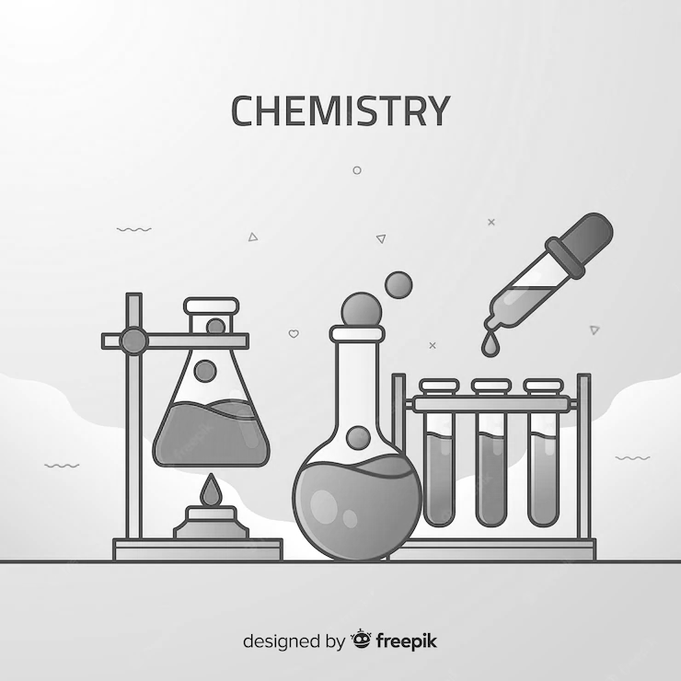

2021 - 2022

**Name : Arnab Chatterjee**

**Class : XII – Sc**

**Roll : 12659416**

**Topic : Neutralisation Power of Hcl**